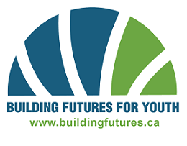
BFY Community Reference
Name
Phone
Email

STUDENTS complete the above information, and ask the remainder of the form to be completed by someone who is NOT a family member (who you have regular contact with in recent years).

Reference Name
Phone

How do you know the student?

How long have you known the student? ________________________________________________

Please check the attributes you believe the student demonstrates well:

- Punctual & Dependable
- Reliable Independent Work
- Teamwork Skills
- Takes Initiative
- Proper Time Management
- Maturity
- Accountability
- Positive Attitude
- Safety Conscience
- Respectful of Others

The Building Futures for Youth program offers students the opportunity to gain valuable Safety training, earn high school credits and Apprenticeship hours, and explore a construction career through a paid summer job. Please tell us why you feel the Student is a good candidate for Building Futures for Youth.

Reference Signature________________________________________ Date____________________

